University of British Columbia

Electrical and Computer Engineering
Digital Design and Microcomputers
ELEC291/CPEN312

Debugging Assembly Programs with CMON51 in the CV-8052 Soft-Processor
Copyright © 2011-2026, Jesus Calvino-Fraga. Not to be copied, used, or revised without explicit written permission from the copyright owner

Introduction
This document describes how to use the 8051 monitor CMON51 in the CV-8052 soft processor to debug assembly code. CMON51 uses the USB port of the Altera DE0-CV to communicate with the program Quartus_stp.exe provided by Altera with Quartus II.

Starting CMON51 via USB blaster

To run CMON51 in the CV-8052 soft-processor, press and hold button ‘KEY3’ while pressing and releasing button ‘FPGA_RESET’. The message ‘dEbUGG’ is displayed in the 7-segment displays. To access CMON51 from the host computer a TCL script compatible with Quaturs_stp.exe is provided: cmon51.tcl. To start the debug session type in a command prompt:

"C:\intelFPGA_lite\23.1std\quartus\bin64\quartus_stp.exe" -t "cmon51.tcl"

Please note that the complete path of ‘quatus_stp.exe’ must be provided and match the Quartus II installation in the current computer. For your convenience, a Windows batch file, ‘cmon51.bat’ is also provided, but it must be edited so the path of ‘quartus_stp.exe’ is valid. A debug session can be quickly started by double-clicking ‘cmon51.bat’ from Windows Explorer, as described in the paragraphs below.

Starting a CMON51 Debug Session using the Serial Port

If a serial port is attached to the CV-8052, it is possible to use it as the console for the debugging session. Configure your serial terminal for 115200 baud, 8 bits, no parity. For the debug session to start using the port, pin P3.3 must be zero. This can be achieved with a jumper between pins 30 and 32 of connector GPIO in the DE10-Lite board as shown in the picture below. For other boards (DE0-CV and DE1-SoC) check the corresponding documentation for the location of pin P3.3.
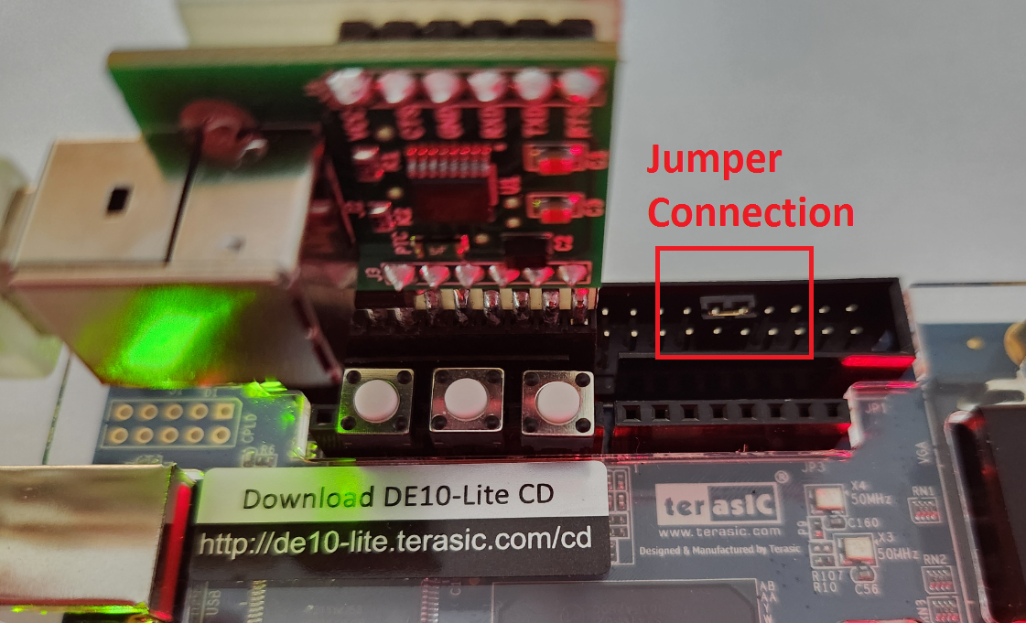

Debugging Session Example
To demonstrate the use of CMON51, let us start with the small 8051 assembly program shown below. The program is supposed to add 99H to the accumulator and save the result into register B. The target processor is the CV-8052 soft processor. We will be using CrossIDE to edit, compile, and flash our code into the processor.
$MODDE0CV

org 0000H
ljmp myprogram

myprogram:
mov SP, #7FH

mov a, #10H
add a, 99H
mov b, a

forever:
sjmp forever
END

The code above is assembled normally using A51 as shown in the figure below:

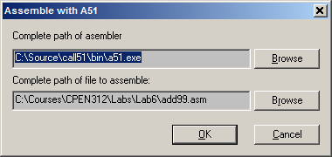

After assembling the code, the corresponding “add99.HEX” file is generated. Now we ‘flash’ that file to the CV-8052 soft-processor:

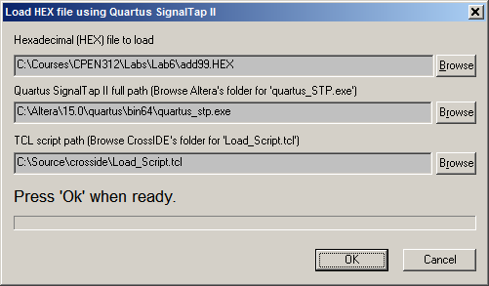

To start the debug session, double click “cmon51.bat”. A TCL console window pops open. Pressing and holding button KEY3 while pressing and releasing the FPAG_RESET button in the DE0-CV board starts CMON51, which prints the information shown below.

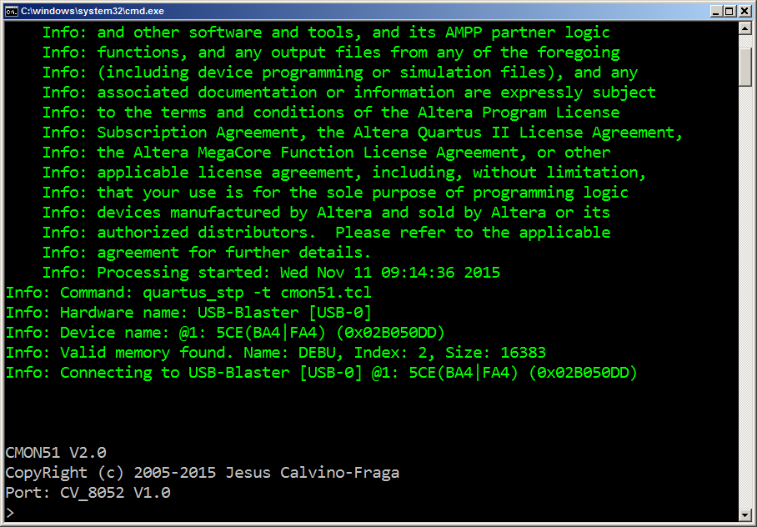

At this point we can start debugging our code. For example, let us run the “Registers”, “Dis-assemble”, and “Single Step” commands and see what happens when each line of the program is executed:

> r
A =00 B =00 SP=7F IE=00 DPH=00 DPL=00 PSW=00 PC=0003
R0=00 R1=00 R2=00 R3=00 R4=00 R5=00 R6=00 R7=00 BANK 0
> u 3
0003: 75 81 7F mov SP,#7F
> s
A =00 B =00 SP=7F IE=00 DPH=00 DPL=00 PSW=00 PC=0006
R0=00 R1=00 R2=00 R3=00 R4=00 R5=00 R6=00 R7=00 BANK 0
0006: 74 10 mov a,#10
> s
A =10 B =00 SP=7F IE=00 DPH=00 DPL=00 PSW=01 PC=0008
R0=00 R1=00 R2=00 R3=00 R4=00 R5=00 R6=00 R7=00 BANK 0
0008: 25 99 add a,SBUF
> s
A =10 B =00 SP=7F IE=00 DPH=00 DPL=00 PSW=01 PC=000A
R0=00 R1=00 R2=00 R3=00 R4=00 R5=00 R6=00 R7=00 BANK 0
000A: F5 F0 mov B,a
> s
A =10 B =10 SP=7F IE=00 DPH=00 DPL=00 PSW=01 PC=000C
R0=00 R1=00 R2=00 R3=00 R4=00 R5=00 R6=00 R7=00 BANK 0
000C: 80 FE sjmp 000C
> s
A =10 B =10 SP=7F IE=00 DPH=00 DPL=00 PSW=01 PC=000C
R0=00 R1=00 R2=00 R3=00 R4=00 R5=00 R6=00 R7=00 BANK 0
000C: 80 FE sjmp 000C
>
Notice from the step by step execution above that the “add a, SBUF” instruction “was not” in our code. Actually I made a mistake (intentionally!) when writing the code by missing the ‘direct’ operator ‘#” before the add instruction. Therefore the assembler assumed that we were using SFR SBUF (whose address is 99H) instead of number 99H. The corrected source code is shown below:

$MODDE0CV

org 0000H
ljmp myprogram

myprogram:
mov SP, #7FH

mov a, #10H
add a, #99H
mov b, a

forever:
sjmp forever
END

Before loading the code into the CV-8052 soft-processor, we need to tell Quartus_stp.exe to release the USB port so CrossIDE can use to program the flash memory with the new program:

> hang
Info: Disconnecting from USB-Blaster [USB-0] @1: 5CE(BA4|FA4) (0x02B050DD)
Press Enter to reconnect...

When the fixed code is run step by step using the debugger (following the steps described above) the program behaves as expected:

> r
A =00 B =00 SP=07 IE=00 DPH=00 DPL=00 PSW=00 PC=0003
R0=00 R1=00 R2=00 R3=00 R4=00 R5=00 R6=00 R7=00 BANK 0
> u 3
0003: 75 81 7F mov SP,#7F
> s
A =00 B =00 SP=7F IE=00 DPH=00 DPL=00 PSW=00 PC=0006
R0=00 R1=00 R2=00 R3=00 R4=00 R5=00 R6=00 R7=00 BANK 0
0006: 74 10 mov a,#10
> s
A =10 B =00 SP=7F IE=00 DPH=00 DPL=00 PSW=01 PC=0008
R0=00 R1=00 R2=00 R3=00 R4=00 R5=00 R6=00 R7=00 BANK 0
0008: 24 99 add a,#99
> s
A =A9 B =00 SP=7F IE=00 DPH=00 DPL=00 PSW=00 PC=000A
R0=00 R1=00 R2=00 R3=00 R4=00 R5=00 R6=00 R7=00 BANK 0
000A: F5 F0 mov B,a
> s
A =A9 B =A9 SP=7F IE=00 DPH=00 DPL=00 PSW=00 PC=000C
R0=00 R1=00 R2=00 R3=00 R4=00 R5=00 R6=00 R7=00 BANK 0
000C: 80 FE sjmp 000C
> s
A =A9 B =A9 SP=7F IE=00 DPH=00 DPL=00 PSW=00 PC=000C
R0=00 R1=00 R2=00 R3=00 R4=00 R5=00 R6=00 R7=00 BANK 0
000C: 80 FE sjmp 000C
>

As expected, the accumulator ends up with the right result 10H+99H=0A9H.

CMON51 Command Summary

Single Step
Syntax:
s [n]

Description:

Execute [n] assembly instructions starting from the current program counter. After executing the current assembly instruction the registers and the next instruction are displayed.

Examples:
> s

A =00 B =00 SP=7F IE=00 DPH=00 DPL=00 PSW=00 PC=01A6
R0=00 R1=00 R2=00 R3=00 R4=00 R5=00 R6=00 R7=00 BANK 0
01A6: E4 clr a
> s

A =00 B =00 SP=7F IE=00 DPH=00 DPL=00 PSW=00 PC=01A7
R0=00 R1=00 R2=00 R3=00 R4=00 R5=00 R6=00 R7=00 BANK 0
01A7: F5 E8 mov LEDRA,a
>

Step until Address
Syntax:
t [address]

Description:

This command is similar to the step (‘S’) command, but single steps will be executed until the program counter (PC) reaches [address]. Every instruction will be displayed in the terminal as it is executed. When the PC reaches [address] the registers and the next instruction to be executed are displayed in the screen.

Example:

> t 33bc

33AE: 74 F0 mov a,#F0
33B0: 55 89 anl a,TMOD
33B2: 44 01 orl a,#01
33B4: F5 89 mov TMOD,a
33B6: 75 8A EA mov TL0,#EA
33B9: 75 8C 03 mov TH0,#03

A =21 B =00 SP=5C IE=80 DPH=00 DPL=00 PSW=00 PC=33BC
R0=00 R1=00 R2=00 R3=00 R4=00 R5=00 R6=00 R7=00 BANK 0
33BC: E4 clr a
>

Step Until Address with Registers
Syntax:
tr [address]

Description:

This command is similar to the step until address (‘T’) command, but every instruction will be displayed in the terminal as it is executed along with the registers. When the PC reaches [address] it stops.

Example:

> tr 1b5
01A6: E4 clr a

A =00 B =00 SP=7F IE=00 DPH=00 DPL=00 PSW=00 PC=01A7
R0=00 R1=00 R2=00 R3=00 R4=00 R5=00 R6=00 R7=00 BANK 0
01A7: F5 E8 mov LEDRA,a

A =00 B =00 SP=7F IE=00 DPH=00 DPL=00 PSW=00 PC=01A9
R0=00 R1=00 R2=00 R3=00 R4=00 R5=00 R6=00 R7=00 BANK 0
01A9: F5 95 mov LEDRB,a

A =00 B =00 SP=7F IE=00 DPH=00 DPL=00 PSW=00 PC=01AB
R0=00 R1=00 R2=00 R3=00 R4=00 R5=00 R6=00 R7=00 BANK 0
01AB: F5 9E mov LEDRC,a

A =00 B =00 SP=7F IE=00 DPH=00 DPL=00 PSW=00 PC=01AD
R0=00 R1=00 R2=00 R3=00 R4=00 R5=00 R6=00 R7=00 BANK 0
01AD: F5 F8 mov LEDG,a

A =00 B =00 SP=7F IE=00 DPH=00 DPL=00 PSW=00 PC=01AF
R0=00 R1=00 R2=00 R3=00 R4=00 R5=00 R6=00 R7=00 BANK 0
01AF: F5 30 mov 30,a

A =00 B =00 SP=7F IE=00 DPH=00 DPL=00 PSW=00 PC=01B1
R0=00 R1=00 R2=00 R3=00 R4=00 R5=00 R6=00 R7=00 BANK 0
01B1: F5 31 mov 31,a

A =00 B =00 SP=7F IE=00 DPH=00 DPL=00 PSW=00 PC=01B3
R0=00 R1=00 R2=00 R3=00 R4=00 R5=00 R6=00 R7=00 BANK 0
01B3: F5 32 mov 32,a

A =00 B =00 SP=7F IE=00 DPH=00 DPL=00 PSW=00 PC=01B5
R0=00 R1=00 R2=00 R3=00 R4=00 R5=00 R6=00 R7=00 BANK 0
01B5: F5 33 mov 33,a
>

Go
Syntax:
g

Description:

Execute the user code from the current program counter.

Example:

> g

Set Breakpoint
Syntax:
bron [address]

Description:

This command sets a breakpoint at the given address. Upon execution of the ‘go’ command and after the running program reaches the given address, the user program stops and Cmon51 is reactivated showing the registers.

Example:

> u 0 10
0000: 02 E0 00 ljmp E000
0003: 7A 1E mov r2,#1E
0005: 79 FA mov r1,#FA
0007: 78 FA mov r0,#FA
0009: D8 FE djnz r0,0009
000B: D9 FA djnz r1,0007
000D: DA F6 djnz r2,0005
000F: 22 ret
0010: 75 81 7F mov SP,#7F
0013: 75 E8 00 mov LEDRA,#00
0016: 75 95 00 mov LEDRB,#00
0019: 75 9E 00 mov LEDRC,#00
001C: 75 F8 00 mov LEDG,#00
001F: B2 E8 cpl LEDRA.0
0021: 12 00 03 lcall 0003
0024: 80 F9 sjmp 001F
> bron 000F
> g

A =00 B =00 SP=81 IE=00 DPH=00 DPL=00 PSW=00 PC=000F
R0=00 R1=00 R2=00 R3=00 R4=00 R5=00 R6=00 R7=00 BANK 0
000F: 22 ret
>

Clear Breakpoint
Syntax:
broff [address]

Description:

This command clears a breakpoint at the given address.

Example:
> broff 000F

List Breakpoints
Syntax:
brl

Description:

This command lists all the activated breakpoints.

Example:
> brl
000F
001F
>000F

Clear all Breakpoints
Syntax:
brc

Description:

This command clears all breakpoints.

Example:
> brl
000F
001F
> brc
> brl
>

Display Registers

Syntax:
r

Description:

Display the microcontroller's main registers.

Example:

> r

A =00 B =00 SP=81 IE=00 DPH=00 DPL=03 PSW=00 PC=00F9
R0=00 R1=00 R2=00 R3=00 R4=00 R5=00 R6=00 R7=00 BANK 0

Dis-assemble

Syntax:
u [address] [number]

Description:

Disassemble [number] opcodes starting at [address].

Example:

> u e000 10
E000: 02 E0 06 ljmp E006
E003: 02 ED 11 ljmp ED11
E006: 75 81 60 mov SP,#60
E009: 12 E0 60 lcall E060
E00C: E5 82 mov a,DPL
E00E: 60 03 jz E013
E010: 02 E0 57 ljmp E057
E013: 75 82 00 mov DPL,#00
E016: 75 83 00 mov DPH,#00
E019: 75 84 00 mov 84,#00
E01C: 75 85 00 mov 85,#00
E01F: 78 00 mov r0,#00
E021: 79 00 mov r1,#00
E023: E8 mov a,r0
E024: 49 orl a,r1
E025: 60 12 jz E039
>

Display Data Memory

Syntax:
d

Description:

Display data memory.

Example:

> d
D:00: 00 00 00 00 00 00 00 00-A3 01 00 00 00 00 00 00 ................
D:10: 00 00 00 00 00 00 00 00-00 00 00 00 00 00 00 00 ................
D:20: 00 00 00 00 00 00 00 00-00 00 00 00 00 00 00 00 ................
D:30: 00 00 00 00 00 00 00 00-00 00 00 00 00 00 00 00 ................
D:40: 00 00 00 00 00 00 00 00-00 00 00 00 00 00 00 00 ................
D:50: 00 00 00 00 00 00 00 00-00 00 00 00 00 00 00 00 ................
D:60: 00 00 00 00 00 00 00 00-00 00 00 00 00 00 00 00 ................
D:70: 00 00 00 00 00 00 00 00-00 00 00 00 00 00 00 00 ................

Display Idata Memory

Syntax:
i

Description:

Display idata memory.

Example:

> i
I:80: BF 01 F9 00 00 00 03 00-03 00 00 00 00 00 00 00 ................
I:90: 00 00 57 00 8C 03 69 01-A4 00 46 AB 00 00 00 00 ..W...i...F.....
I:A0: 00 00 00 00 00 00 00 00-00 00 00 00 00 00 00 00 ................
I:B0: 00 00 00 00 00 00 00 00-00 00 00 00 00 00 00 00 ................
I:C0: 00 00 00 00 00 00 00 00-00 00 00 00 00 00 00 00 ................
I:D0: 00 00 00 00 00 00 00 00-00 00 00 00 00 00 00 00 ................
I:E0: 00 00 00 00 00 00 00 00-00 00 00 00 00 00 00 00 ................
I:F0: 00 00 00 00 00 00 00 00-00 00 00 00 00 00 00 00 ................

Display Expanded Memory

Syntax:
x [address] [number]

Description:

Display [number] of external data bytes starting at [address].

Example:

> x 0 40
X:0000: E3 F1 5B EC 5C 6B 87 8B-BA C0 BF 3F 59 E8 D7 FF ..[.\k.....?Y...
X:0010: DF 9E 66 31 9F 2C F5 8D-66 FF FE 55 7E DF 64 91 ..f1.,..f..U~.d.
X:0020: FE A2 97 8E 7A 25 F4 22-E0 AD F5 F8 B7 B3 D6 2E ....z%."........
X:0030: DE 6F ED 66 B7 9E 2F FA-7F 4B CB BE A9 F9 FF 7F .o.f../..K......

Display Code Memory

Syntax:
c [address] [number]

Description:

Display [number] of code data bytes starting at [address].

Example:

> c 100 30
C:0100: 80 37 30 F1 04 7F 01 80-30 30 F2 04 7F 02 80 29 .70.....00.....)
C:0110: 30 F3 04 7F 03 80 22 30-F4 04 7F 04 80 1B 30 F5 0....."0......0.
C:0120: 04 7F 05 80 14 30 F6 04-7F 06 80 0D 7F 07 80 09 .....0..........

Fill Data Memory

Syntax:
fd [address] [number] [value]

Description:

Fill [number] of internal data bytes starting at [address] with
[value].

Example:
> fd 0 10 55
> d
D:00: 55 55 55 55 55 55 55 55-55 55 55 55 55 55 55 55 UUUUUUUUUUUUUUUU
D:10: 00 00 00 00 00 00 00 00-00 00 00 00 00 00 00 00 ................
D:20: 00 00 00 00 00 00 00 00-00 00 00 00 00 00 00 00 ................
D:30: 00 00 00 00 00 00 00 00-00 00 00 00 00 00 00 00 ................
D:40: 00 00 00 00 00 00 00 00-00 00 00 00 00 00 00 00 ................
D:50: 00 00 00 00 00 00 00 00-00 00 00 00 00 00 00 00 ................
D:60: 00 00 00 00 00 00 00 00-00 00 00 00 00 00 00 00 ................
D:70: 00 00 00 00 00 00 00 00-00 00 00 00 00 00 00 00 ................

Fill Idata Memory

Syntax:
fi [address] [number] [value]

Description:

Fill [number] of indirect internal data bytes starting at [address] with
[value].

Example:
> fi 80 20 aa
> i
I:80: AA AA AA AA AA AA AA AA-AA AA AA AA AA AA AA AA ................
I:90: AA AA AA AA AA AA AA AA-AA AA AA AA AA AA AA AA ................
I:A0: 00 00 00 00 00 00 00 00-00 00 00 00 00 00 00 00 ................
I:B0: 00 00 00 00 00 00 00 00-00 00 00 00 00 00 00 00 ................
I:C0: 00 00 00 00 00 00 00 00-00 00 00 00 00 00 00 00 ................
I:D0: 00 00 00 00 00 00 00 00-00 00 00 00 00 00 00 00 ................
I:E0: 00 00 00 00 00 00 00 00-00 00 00 00 00 00 00 00 ................
I:F0: 00 00 00 00 00 00 00 00-00 00 00 00 00 00 00 00 ................

Fill Expanded Memory

Syntax:
fx [address] [number] [value]

Description:

Fill [number] of expanded data bytes starting at [address] with [value].

Example:

> x 0 20
X:0000: E3 F1 5B EC 5C 6B 87 8B-BA C0 BF 3F 59 E8 D7 FF ..[.\k.....?Y...
X:0010: DF 9E 66 31 9F 2C F5 8D-66 FF FE 55 7E DF 64 91 ..f1.,..f..U~.d.
> fx 0 20 0
> x 0 20
X:0000: 00 00 00 00 00 00 00 00-00 00 00 00 00 00 00 00 ................
X:0010: 00 00 00 00 00 00 00 00-00 00 00 00 00 00 00 00 ................

Display/Change General Purpose Registers

Syntax:
r0[=value]
r1[=value]
r2[=value]
r3[=value]
r4[=value]
r5[=value]
r6[=value]
r7[=value]

Description:

Display the selected register or changes it to [value].

Example:

> r0=01
> r0
01

Notes:

The r0 to r7 commands display/change the register from the register bank selected with bits RS0 and RS1 of the PSW register.

Hang

Syntax:
hang

Description:

Releases the USB blaster port so it can be used by another application

Example:

> hang
Info: Disconnecting from USB-Blaster [USB-0] @1: 5CE(BA4|FA4) (0x02B050DD)
Press Enter to reconnect...

Modify Data Memory

Syntax:
md [address]

Description:

Modify data memory starting at [address].

Example:

> md 30
D:30= 55
D:31= 66
D:32= 77
D:33= 'Hello'
D:38= q
> d
D:00: 00 00 00 00 00 00 00 00-00 00 00 00 00 00 00 00 ................
D:10: 00 00 00 00 00 00 00 00-00 00 00 00 00 00 00 00 ................
D:20: 00 00 00 00 00 00 00 00-00 00 00 00 00 00 00 00 ................
D:30: 55 66 77 48 65 6C 6C 6F-00 00 00 00 00 00 00 00 UfwHello........
D:40: 00 00 00 00 00 00 00 00-00 00 00 00 00 00 00 00 ................
D:50: 00 00 00 00 00 00 00 00-00 00 00 00 00 00 00 00 ................
D:60: 00 00 00 00 00 00 00 00-00 00 00 00 00 00 00 00 ................
D:70: 00 00 00 00 00 00 00 00-00 00 00 00 00 00 00 00 ................

Modify Idata Memory

Syntax:
mi [address]

Description:

Modify idata memory starting at [address].

Example:

> mi a0

> mi a0
I:A0= 55
I:A1= 55
I:A2= 20
I:A3= 'ABC'
I:A6= q

> i
I:80: 00 00 00 00 00 00 00 00-00 00 00 00 00 00 00 00 ................
I:90: 00 00 00 00 00 00 00 00-00 00 00 00 00 00 00 00 ................
I:A0: 55 55 20 41 42 43 00 00-00 00 00 00 00 00 00 00 UU.ABC..........
I:B0: 00 00 00 00 00 00 00 00-00 00 00 00 00 00 00 00 ................
I:C0: 00 00 00 00 00 00 00 00-00 00 00 00 00 00 00 00 ................
I:D0: 00 00 00 00 00 00 00 00-00 00 00 00 00 00 00 00 ................
I:E0: 00 00 00 00 00 00 00 00-00 00 00 00 00 00 00 00 ................
I:F0: 00 00 00 00 00 00 00 00-00 00 00 00 00 00 00 00 ................

Modify Expanded Memory

Syntax:
mx [address]

Description:

Modify expanded memory starting at [address].

Example:

> mx 200
X:0200= 00
X:0201= 11
X:0202= 22
X:0203= 33
X:0204= q

> x 200 10
X:0200: 00 11 22 33 00 00 00 00-00 00 00 00 00 00 00 00 .."3............

Modify Code Memory

Syntax:
mc [address]

Description:

Modify code memory starting at [address]. Note: These changes are not stored in flash memory. After a reset, the code memory is restored to its original values.

Example:

> mc 10
C:0010= 'Hello!'
C:0016= 00
C:0017= q

> c 10 10
C:0010: 48 65 6C 6C 6F 21 00 00-00 00 00 00 00 00 00 00 Hello!..........

Display/Change Special Function Registers

Syntax:
ACC[=value]
A[=value]
PC[=value]
PSW[=value]
B[=value]
IE[=value]
DPL[=value]
DPH[=value]
DPTR[=value]
SP[=value]
Any_SFR_name[=value]

Description:

Display the selected register or changes it to [value]. Any SFR name for the current processor can be displayed or changed this way. For most SFR, bits values can also be changed individually by using the SFR name followed by period (‘.’) and the bit number. This works even for non-bit-addressable SFR, if the SFR can be read by the Cmon51.

Examples:

> ACC
00
> ACC.1=1
> ACC
02

Display/Change Special Function Bits

Syntax:
CY[=value]
AC[=value]
FO[=value]
RS1[=value]
RS0[=value]
OV[=value]
UD[=value]
P[=value]
[Any SFR bit name][=value]

Description:

Display the selected bit or changes it to [value]. Any read/write SFR bit for the current microcontroller can be displayed or changed this way.

Examples:

> cy=1
> cy
1
> cy=0
> cy
0
> LEDRA.0=1

Display/Change Special Function Bits

Syntax:
exit

Description:
Terminates the debug session.

Example:

> exit
Info (23030): Evaluation of Tcl script cmon51.tcl was successful
Info: Quartus II 64-Bit SignalTap II was successful. 0 errors, 0 warnings
Info: Peak virtual memory: 370 megabytes
Info: Processing ended: Wed Nov 11 10:39:37 2015
Info: Elapsed time: 00:33:07
Info: Total CPU time (on all processors): 00:00:34

Recent versions of the assembler will warn about this kind of mistakes.

